**URL: http://www.edcamro.com/**

Our staff is trained to give you their full attention and focus on your needs because we care. Come visit us, you'll be pleasantly surprised.

Our waiting area has a free Wi-Fi internet connection and you can ask our receptionist for any kind of hot or cold drinks for your own comfort.

**Pain Free**

Modern dentistry can be surprisingly pain-free. We have the latest Needle-Less Injector that can allow pain-free procedures.

### Infection Free

Our center is supplied with the latest infection control methods to prevent infection. We do our sterilization using the Autoclave for all our instruments including the hand pieces.

## Our Mission

Our mission is to offer our clients the opportunity to achieve optimum dental health through excellent diagnosis and high quality dentistry, treating each patient the way we ourselves would like to be treated.

#### Patient Safety

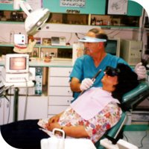To protect our patients and ourselves, our staff wear masks, gloves, glasses. All instruments are cleaned and routinely sterilized. Whenever possible, disposable instruments are used to ensure safety.

Handpieces are sterilized in the autoclave, and all surfaces are disinfected after each patient.

We know that visiting the dentist makes the patient feels anxious, so we try to do our best to make this anxiety to a minimum by using topical and local anesthetics.

Our easy to locate Center, is in a quiet area Ground floor no stairs or ramps, with beautiful flowery garden, and plenty of parkings free for your cars. Near firas Circle the Center of Jabal Al Hussein which is considered the Heart of  Ammanthe Capital of Jordan.

Hygiene: An important part of maintaining your teeth for life is the removal of plaque and tartar regularly. During your visit you will update your medical history, check your teeth for cavities, review oral hygiene instructions and monitor your gum condition.

Doctor’s credentials

# [Esthetic Dental Center - Amman Jordan](http://www.edcamro.com/)

## Contact Us

Top of Form

Bottom of Form

**Tel:** +962 6 56 61 802  
**Mobile:** +962 79 555 0601  
Amman 11192, Jordan

**Email:**[dramr@edcamro.com](mailto:dramr@edcamro.com)

* [FAQ](http://www.edcamro.com/2008/content/faq.php)
* [Esthetic Dental Center Location: Amman, Jordan](http://www.edcamro.com/2008/content/location.php)
* [Befaore and Aftre Cases](http://www.edcamro.com/2008/content/cases.php)
* [Home](http://www.edcamro.com/)
* [Staff](http://www.edcamro.com/2008/content/staff.php)
* [Why Us](http://www.edcamro.com/2008/content/whyUs.php)
* [Services](http://www.edcamro.com/2008/content/services.php)
* [News](http://www.edcamro.com/2008/content/news.php)
* [Appointments](http://www.edcamro.com/2008/content/appointments.php)
* [Location](http://www.edcamro.com/2008/content/location.php)

## EDC Staff

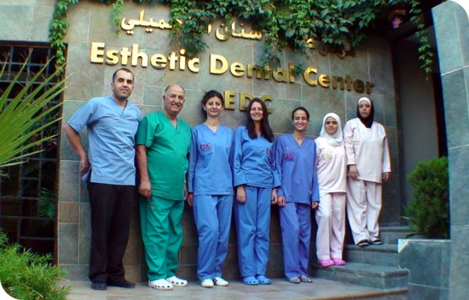

|  |  |  |  |  |  |  |
| --- | --- | --- | --- | --- | --- | --- |
| |  |  | | --- | --- | | Dentist Munir Amro | **Dr. Munir Amro** D.D.S. FICCDE - Director of the Center |  * Has been serving the dental needs since 1964.  |  | | --- | |  | | |  | | --- | |  | | | http://www.edcamro.com/2008/images/frame_bottom.gif |  * He received his Bachelor degree in Dentistry from Istanbul University. * He committed himself to on-going continuing education. * Dr. Amro International speaker attended Dental Congresses all over the world has completed more than 1000 hours in advanced dental courses. * In 1998 he was chosen to be the chief of the International Affairs Committee in the JDA. Then was appointed as APDF/APRO Coordinator. * During the congress held in Taipei / China in April 2001, He was elected officially as a REGIONAL REPRESENTATIVE OF THE ASIAN PACIFIC DENTAL FEDERATION and ASIAN PACIFIC REGIONAL ORGAINZATION (APDF/APRO) in the Middle East Countries. * In October 2002, he was chosen to be A MEMBER IN THE BOARD OF DIRECTORS of the International College of Continuing Dental Education (ICCDE). * In May 2003, he became a FELLOW (FICCDE) of the International College of Continuing Dental Education (ICCDE) due to his distinguished contribution in the dental field. * Elected as a Vice President for THE ASIAN PACIFIC DENTAL FEDERATION APDF / APRO during the 28th APDC held in Karachi / Pakistan 2006. * DR AMRO is Affiliate member of the American Dental Association (ADA) and Membership of the International College of Implantology (New York – USA). |
| * Graduated in the year 2000 and took his masters in Surgery in the year 2007 * Attended many International dental congresses * Writes many articles in Internation Dental Magazines |
| |  |  | | --- | --- | | Dentist Rania Zeina | **Dr. Rania Zeina** Assistant Director of the Center |  * Completed her dental education at the University of Jordan. * Joined our center in the year 1995 till now. * Long dental practice experience. * Mainly Specialized in Root Canal Treatment. * Attended an implant course and other courses in different dental fields. * Attended many dental congresses.   [close [http://www.edcamro.com/2008/images/hide.gif](http://www.edcamro.com/2008/content/staff.php)](http://www.edcamro.com/2008/content/staff.php) |
| |  |  | | --- | --- | | Dentist Maria Dekran | **Dr. Maria Dekran** |  * Graduated in 2006 from Jordan University * Ranked 5th in her class   [close [http://www.edcamro.com/2008/images/hide.gif](http://www.edcamro.com/2008/content/staff.php)](http://www.edcamro.com/2008/content/staff.php) |
| |  |  | | --- | --- | | Miss Alia Ayesh | **Miss Alia Ayesh** |  * She is our talented professional secretary and assistant, with 12 years of experience in our center. * She treats our patients with respect and care.   [close [http://www.edcamro.com/2008/images/hide.gif](http://www.edcamro.com/2008/content/staff.php)](http://www.edcamro.com/2008/content/staff.php) |
| |  |  | | --- | --- | | Miss Nimat Ballout | **Miss Nimat Ballout** |  * She joined our center two years ago as a dental assistant, she has many years experience in the dental field. * Greets every patient, and makes every attempt to set appointments than can suite your personal schedule.   [close [http://www.edcamro.com/2008/images/hide.gif](http://www.edcamro.com/2008/content/staff.php)](http://www.edcamro.com/2008/content/staff.php)  http://www.edcamro.com/2008/images/bullet_blue.gifOur Staff are trained to provide you with exceptional preventive care. They all are responsible for helping you attain optimum dental health. You will enjoy their gentle touch and caring attitude. |

**Services:**

* [**Dental Services**](http://www.edcamro.com/2008/content/services.php#dental)
  1. [Prevention and Cleaning](http://www.edcamro.com/2008/content/services.php#1)
  2. [Restorations](http://www.edcamro.com/2008/content/services.php#2)
  3. [Root Canal Treatment](http://www.edcamro.com/2008/content/services.php#3)
  4. [Orthodontic Treatment (Braces)](http://www.edcamro.com/2008/content/services.php#4)
  5. [Surgical Operations](http://www.edcamro.com/2008/content/services.php#5)
  6. [Teeth Whitening](http://www.edcamro.com/2008/content/services.php#6)
* [**Follow up Services**](http://www.edcamro.com/2008/content/services.php#followup)

### Dental Services

#### 1. Prevention and Cleaning:

* Periodic check-ups every six months.
* Full oral examination, X-rays are taken and tooth by tooth checkup for any new decay.
* Scaling (Cleaning) and removal of the calculus (Studies show that every 1 mm of  calculus contains 250 million organisms which cannot be removed by normal brushing) then polishing to remove any stains and the result would be normal teeth color for extra whitening result see [**Teeth Whitening (Bleaching)**](http://www.edcamro.com/2008/content/services.php#6).
* Fissure sealants are recommended for non-decayed teeth (application which is applied in the fissure areas of the posterior teeth to prevent future caries).
* Fluoride application: for Children under 13 years of age every six months period.

[Go to top of page](http://www.edcamro.com/2008/content/services.php#top)

#### 2. Restorations

A. Fillings:To restore decayed tooth structures to maintain the tooth structure. We provide COMPOSITE (White) fillings and AMALGAM (silver) fillings on choice.

|  |  |
| --- | --- |
| Amalgam Fillings | Composite Fillings |
| AMALGAM fillings | COMPOSITE fillings |

B. Crown and Bridges: We offer only high-quality materials (Porcelain and Inceram). They are strong and long lasting. Special efforts are made to ensure, that they look exactly as real teeth. For more information about the technique check the [**FAQ**](http://www.edcamro.com/2008/content/faq.php).

C. Porcelain Veneers:

* 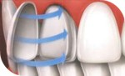They are very thin pieces of tooth shaped porcelain that are custom made (for shape and color) and bonded onto the front of teeth to create a beautiful and attractive smile.
* They are used:
  + Cosmetically, to create a uniform, white, beautiful smile.
  + Crooked teeth.
  + Misshapen teeth.
  + Severely discolored or stained teeth.
  + Teeth that are too small or large.
  + Unwanted or uneven spaces.
  + Worn or chipped teeth.

D. Removable Dentures: Used mostly wherever a fixed prosthesis cannot be used, mostly for financial reasons.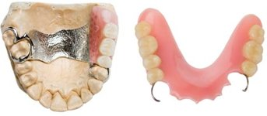  
  
E. Implants: EDC provides top-level implantology treatment with the latest technologies and all existing methods. We have **a solution for every individual case!** For more information about Implantology techniques see the [**FAQ**](http://www.edcamro.com/2008/content/faq.php).

|  |  |
| --- | --- |
| http://www.edcamro.com/2008/images/cases2006/1_b.jpg | http://www.edcamro.com/2008/images/cases2006/1_a.jpg |
| Before | After |

[Go to top of page](http://www.edcamro.com/2008/content/services.php#top)

#### 3. Root Canal Treatment

|  |  |
| --- | --- |
| Root Canal Treatment - Step 1 | We have doctors specialized in Root Canal Treatment and latest technology is used including digital X-rays and Needle-Less Injectors for a painless treatment. For information about the procedure check the [**FAQ**](http://www.edcamro.com/2008/content/faq.php). |

#### 4. Orthodontic Treatment (Braces):

|  |  |
| --- | --- |
| Root Canal Treatment - Step 1 | Our specialist is so talented and uses the latest in orthodontics. We are capable of improving your smile making it more beautiful no matter what was the situation of your teeth. Invisible and Multi-colored braces are available. |

#### 5. Surgical Operations

The center is equipped with all necessary devices and instruments needed for surgical operations like:  
Impacted teeth, apicectomy, frenectomy … As for extraction of the teeth, we believe it is the last choice as we try to protect the natural teeth as much as possible.

#### 6. Teeth Whitening ([Cases](http://www.edcamro.com/2008/content/cases.php#Bleaching))

|  |  |
| --- | --- |
| Teeth Whitening | All whitening methods in our center are utilized to suit individual needs, consisting of materials for home whitening and several methods of professional (In-Office) whitening like Lasers and Zoom3. Read more in [**FAQ**](http://www.edcamro.com/2008/content/faq.php). |

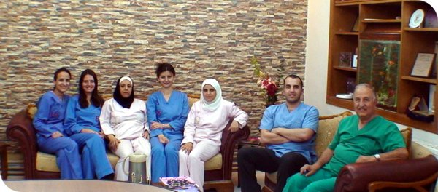

* We beleive people want to keep their teeth for a lifetime and we realize it's easy to forget about setting up regular dental appointments, especially when you are not having any problems.

**Contact us**

**Tel:** +962 6 56 61 802  
**Mobile:** +962 79 555 0601  
Amman 11192, Jordan

**Email:**[dramr@edcamro.com](mailto:dramr@edcamro.com)